Learn to Use Calibre
Lesson Plan for learning how to create content with Audacity
Don Watkins

OVERVIEW & PURPOSE
The Student will learn to install, configure and use the Calibre ebook reader software.

EDUCATION STANDARDS
- ISTE Learning Standard - 3C - Students curate information from digital resources using a variety of tools and methods to create collections of artifacts that demonstrate meaningful connections or conclusions.

OBJECTIVES
- Student will learn how to install Calibre E-book reader
- Student will learn how to create an ‘epub’ file, upload and share it with Calibre
- Student will learn where to look for open educational resources (OER)

MATERIALS NEEDED
- Linux Laptop
- Calibre e-book reader installed
- Access to the Internet
- Open Educational Resources
  - CK12 Flexbooks
  - Open Textbook Library
  - Open SUNY Textbooks
  - Open Textbooks at OER Commons

Instructions
- Install Calibre: $sudo dnf install calibre or $sudo apt install calibre
- Launch Calibre either from the ‘Applications’ menu or the command line.
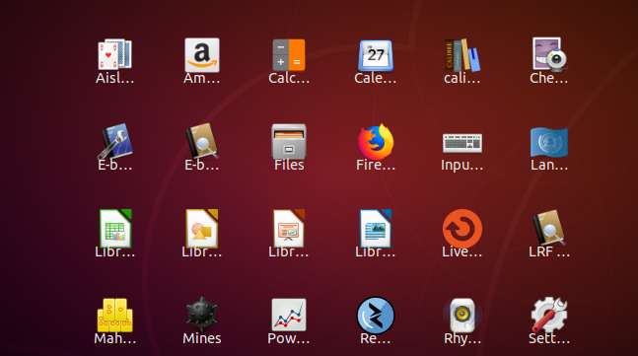
- $ calibre
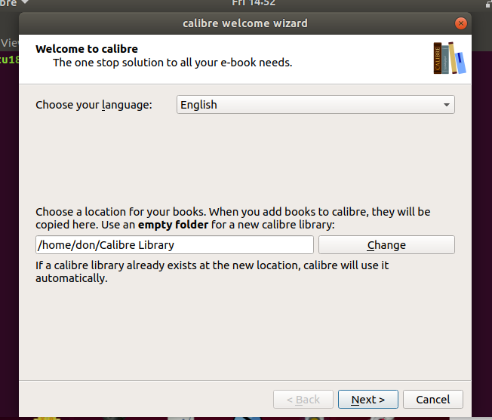
- Add Ebooks and content
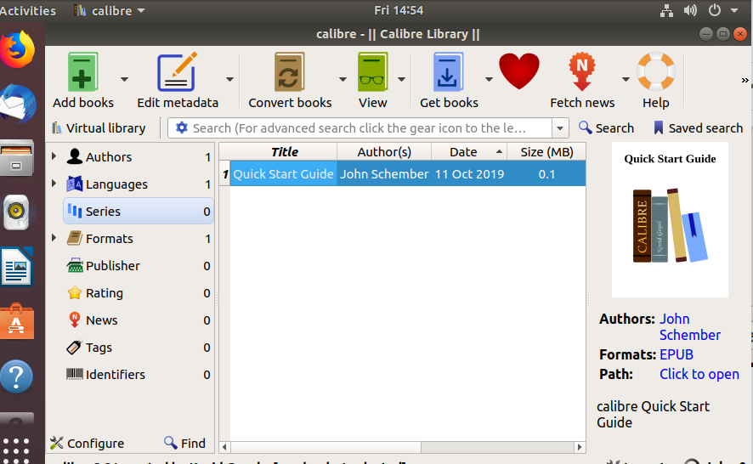
- Get books from sources including Amazon, Gutenberg etc.
  - Un-select all other sources except Gutenberg.
  - Enter ‘Robert Frost’ in the Search Query.
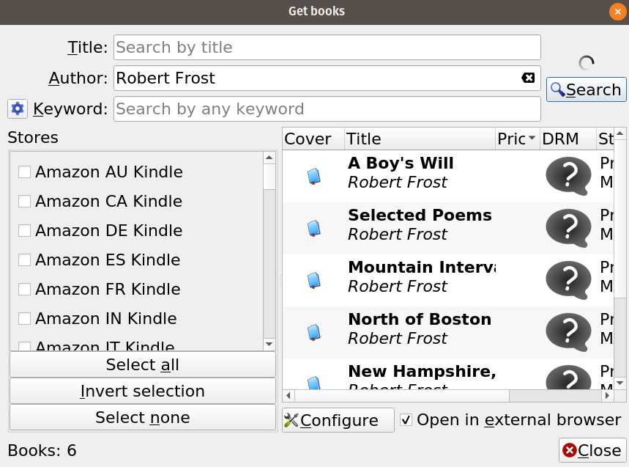
- Select ‘Selected Poems by Robert Frost’.
- Double click on the selection and select the format desired whether
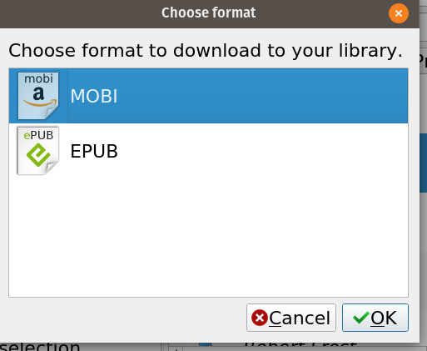
- Selected Poems have been added to the library.
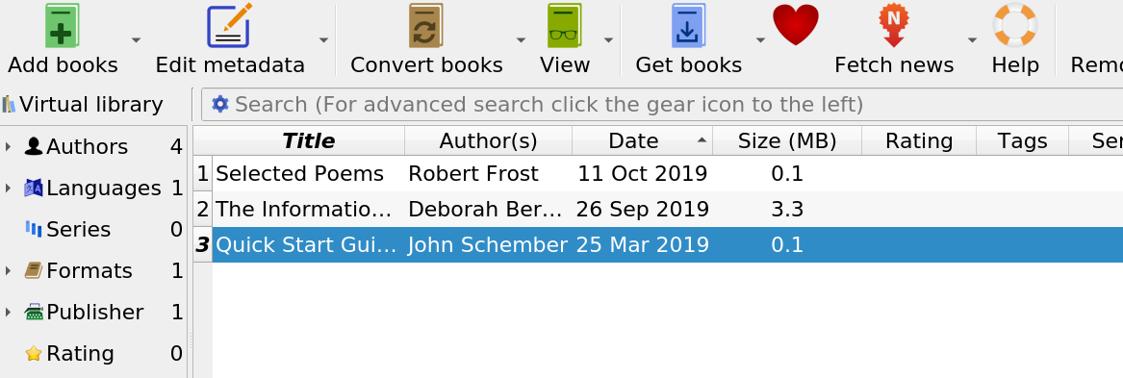
- Double click on the ‘Selected Poems’ in your library and the selection appears in an e-Reader format complete with navigation tools.
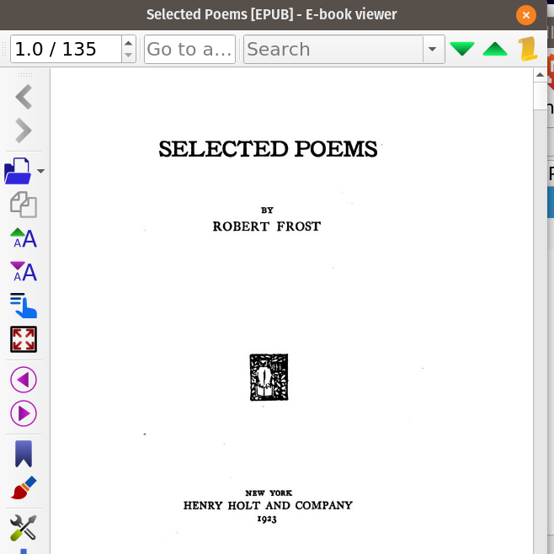
- Download an ebook from the Open Textbook Library and add it to your Calibre library.
  - Point your browser to https://open.umn.edu/opentextbooks/textbooks/making-games-with-python-pygame
  - Note the Creative Commons License - CC by NC-SA (What does that mean?)
  - Click on the “PDF” button and the PDF will download to your computer.
  - Save it to a directory of your choice.
  - Return to Calibre and select ‘Add Books’ from the menu.
  - Click on the PDF ‘makinggames.pdf’ in your ‘Downloads’ folder. Select it and click “Open” and it will be added to your Calibre e-reader.
  - Double-click on the selection and it will open up for you to read.
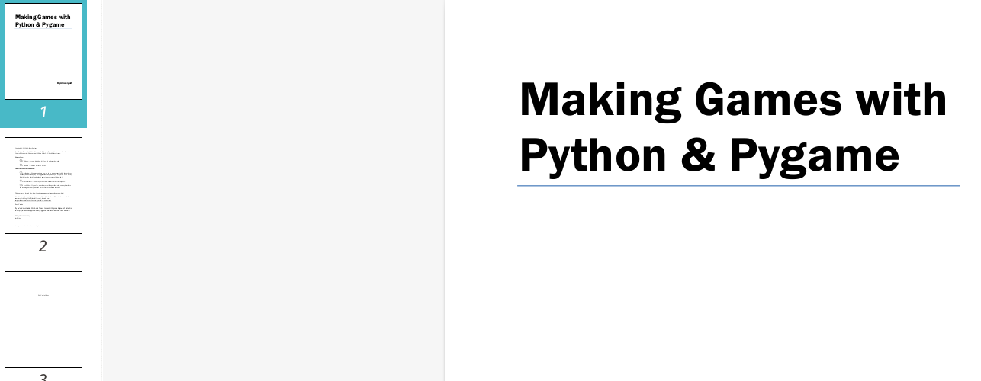

- Setup a classroom E-book server.
  - Start the Ebook server from the menu.
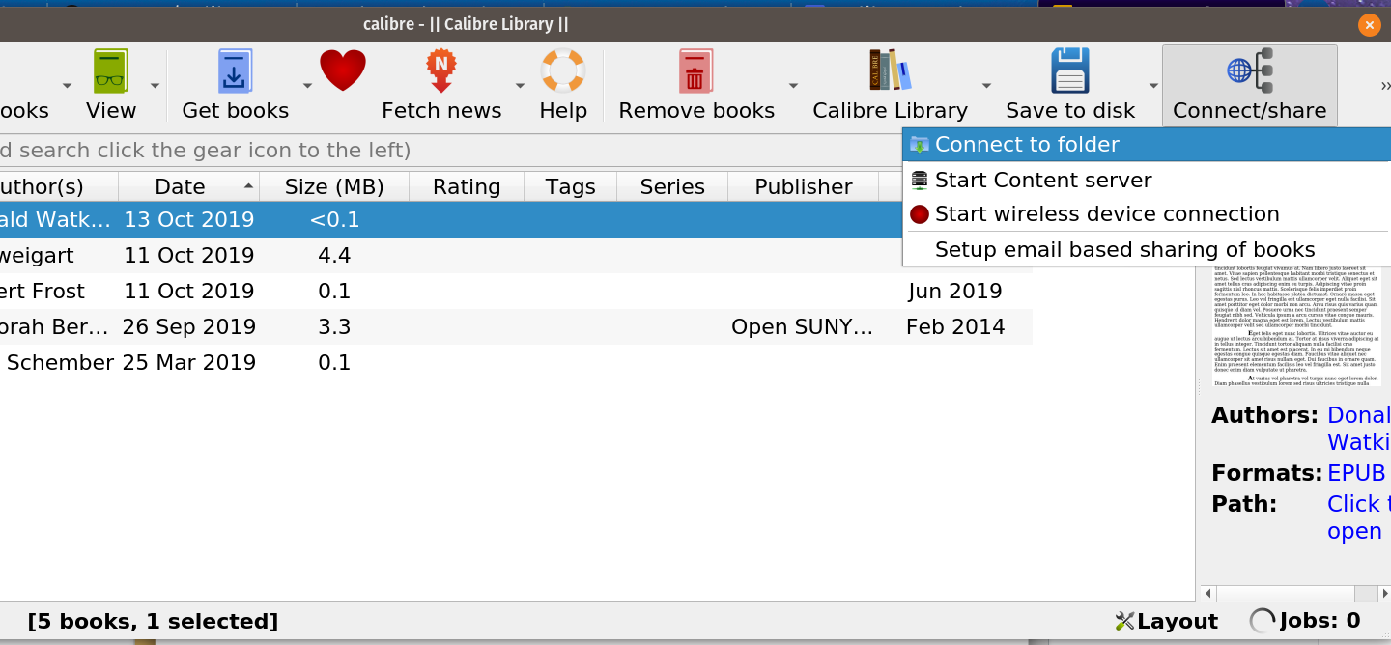b. Point your browser to your server IP address and port 8080. For example https://192.168.2.10:8080. Then you can either download the content or read it online by double clicking on the particular book you want to read and then select ‘Download’ or ‘Read Online.’

Further study :
- https://opensource.com/life/15/1/calibre-ebook-management
- https://calibre-ebook.com/

This work is licensed under a Creative Commons Attribution 4.0 International License.

